A. Actividad 7: It’s time to take the Spanish Club picture for the yearbook, but there are several people who have still not arrived. Andrés, the president, decides to use his cell phone to find out where people are. As you listen to the first part of each conversation, complete the sentences below with the information he finds out. For example, you might write: Beto está en el gimnasio. You will hear each dialogue twice.
Questions (preguntas) | Respuestas (Write your answers here)
- ¿Dónde están los dos profesores de español?
- ¿Dónde está Javier?
- ¿Dónde está Alejandra y Sara?
- ¿Dónde está Mateo?
- ¿Dónde están José y Antonieta?

B. Actividad 9: Listen to two friends talking outside the door of the Spanish Club meeting. They want to go to the meeting, but they are afraid they won’t remember everyone’s names. Look at the drawing. In the grid, write in the name of the person who is being described. You will hear each dialogue twice.
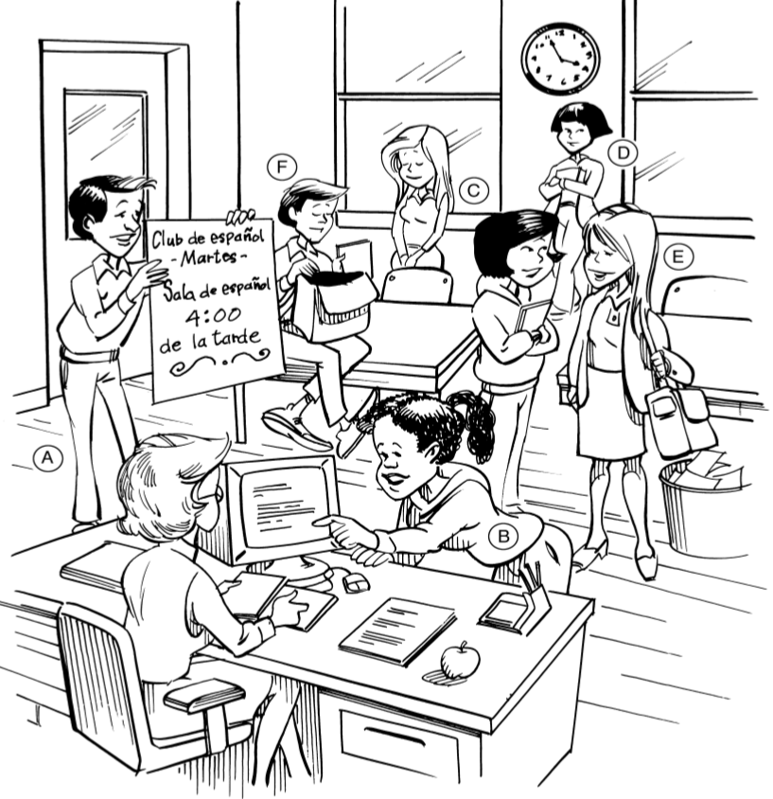
(A) | (B) | (C)
(D) | (E) | (F)
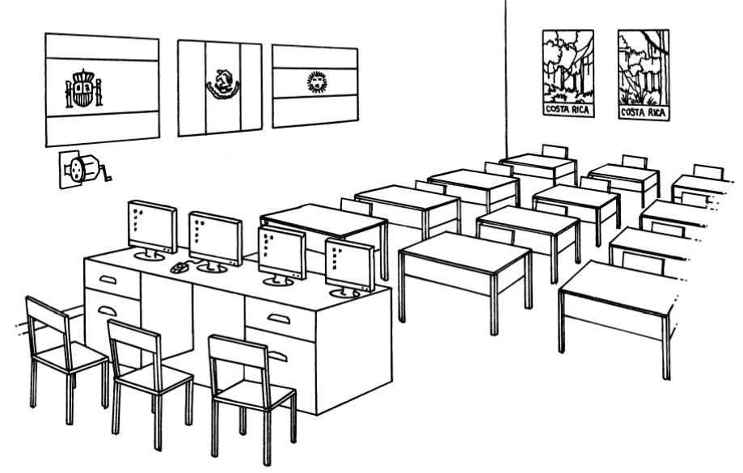
C. Actividad 10: ¿Cuántos hay en la clase?: Answer the questions with complete Spanish sentences based on how many of a certain object there are in the classroom. Follow the model below.
Modelo: ¿Cuántos ratones hay en la clase? Hay un ratón en la clase.
- ¿Cuántos pupitres hay en la clase?

- ¿Cuántas pantallas hay en el salón de clase?

- ¿Cuántas banderas hay en la pared?

- ¿Cuántos carteles hay en la clase?

- ¿Cuántas sillas hay en la clase?

- ¿Cuántas computadoras hay en la clase?

- ¿Cuántas papeleras hay en la clase?

Actividad 13: The two rooms pictured below were once identical, but Sala 2 has been rearranged. Look at each picture carefully. Circle seven items in Sala 2 that are different from Sala 1. Then, write sentences about how Sala 2 is different. Follow the model.
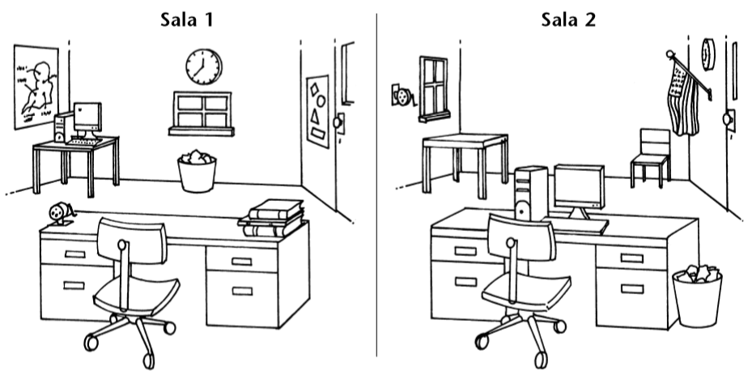
Modelo: En la sala 2 no hay libros encima del escritorio.

