STUDY GUIDE NOMBRE:_____________________________
- GREETINGS

Answer the following questions:
- ¿Cómo te llamas?
- ¿De dónde eres?

- ¿Cuántos años tienes?

- ¿Cómo estás?
Translate:
- Good morning:
- I am fine, thank you:
- Nice to meet you:
- See you later

- LOS NÚMEROS
Write the following numbers in Spanish:
- 58:
- 63:
- 78:
- 87:
- 93:
- 100:

- LOS COLORES
Write the colors in Spanish:

- blue | - orange | - white | - purple
- red | - brown | - pink | - grey
- yellow | - black | - green | - silver

- LA HORA
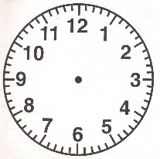
Answer the question with the time given:
- ¿Qué hora es? pm

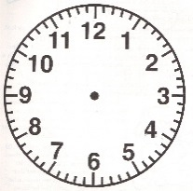
- ¿Qué hora es? pm

- ¿Qué hora es? am

- ¿A qué hora es….? am

- ¿A qué hora es…? pm

- LOS ARTICULOS Y LOS NOMBRES

-Fill in the blank using the appropriate article:

- ________ libros.
For 1-3 Use:
el, la, los, las.
For 4 -6 Use:
un, una, unos, unas.
- ________ hoja.
- ________ estudiante.
- ________ profesora.
- ________ sillas.
- ________ pupitres.

-Change both, the article and the noun to plural:
- El lápiz ___________________________
- Un profesor ___________________________
- Un cuaderno _______________________
- El bolígrafo_________________________
- La carpeta_________________________

- SUBJET PRONOUNS. Write all Spanish subject pronouns in the following chart:
Singular Pronouns | Plural Pronouns
(I) | (we)
(informal you) | (y’all Spain)
(he, she, formal you) | (they, you all Latin America)

- SER. Write a sentence using one element for each columm. Make any necessary changes:
 |  | Alberto y yo |  | estudiante
 |  | ustedes |  | Canadá
 |  | tú | ser | pasajero/a
 |  | las maletas |  | España
 |  | ella |  | profesor(a) de arte
 |  | los lápices |  | el señor Sánchez

1. |  | _______________________________________________________________________________
2. |  | ________________________________________________________________________________
3. |  | _________________________________________________________________________________
4. |  | ________________________________________________________________________________
5. |  | _______________________________________________________________________________
6. |  | _________________________________________________________________________________

1. |  | ¿Qué hora es? Write the times using complete sentences. Follow the model.

modelo
3:00 p.m.
Son las tres de la tarde.

a. |  | 11:15 a.m. _____________________________________________________________________
b. |  | 9:45 p.m. _____________________________________________________________________
c. |  | 12:35 p.m. ______________________________________________________________________
d. |  | 12:00 a.m. _______________________________________________________________________
e. |  | 6:30 a.m. _______________________________________________________________________
f. |  | 7:23 p.m. ________________________________________________________________________
g. |  | 10:10 a.m. ______________________________________________________________________
