Study Guide for Para Empezar Exam

- Can you correctly answer or respond to the following questions or statements?

- ¡Hola!

- ¿Cómo te llamas?

- Mucho gusto.
- ¿De dónde eres?

- ¿Cuántos años tienes?

- ¿Cuándo es tu cumpleaños?

- ¿Cómo estás?

- Adiós

- ¿Cuál es la fecha de hoy? / Qué día es hoy?

- ¿Qué hora es?

- ¿A qué hora es la clase de español? (11:50 a.m.)

- Can you list all the days of the week? C. Can you list the months of the year?
January
February
March
April
May
June
July
August
September
October
November
December

Monday
Tuesday
Wednesday
Thursday
Friday
Saturday
Sunday

D. Can you list the colors in Spanish?
blue | orange | white | purple
red | brown | pink | grey
yellow | black | green | silver

D. Can you list the 4 seasons in Spanish?
1. 2. 3. 4.
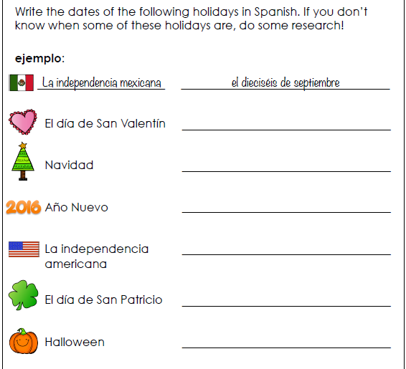
E. Can you tell me the date in Spanish for the following holidays?

- Can you change the singular nouns to be plural?
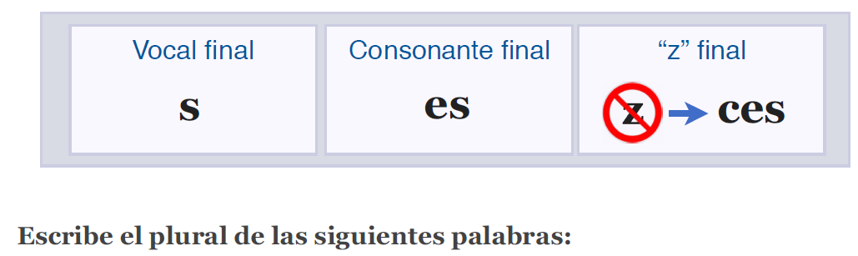

1. el autobús los autobuses
2. la mesa las mesas
3. la matriz las matrices
4. La pizarra _________________________
5. el cartel _________________________
6. la carpeta _________________________
7. la pared _________________________
8. el estudiante _________________________
9. el bolígrafo _________________________
10. el pupitre _________________________
11. la nariz _________________________
12. el papel _________________________
13. la computadora _________________________
14. el sacapuntas _________________________
15. la actriz _________________________
16. el marcador _________________________

- Can you put the correct definite article (el / la / los / las) to say “the” in front of each word? Remember to match the number and gender!
L O N E R S & D IÓN Z A

1. ______ gatos
2. ______ pizarra
3. ______ tenis
4. ______ fútbol
5. ______ jugadores
6. ______ sandalias
7. ______ práctica
8. ______ marcadores
9. ______ canción
10. ______ relojes
11. ______ autobús
12. ______ jugador
13. ______ computadoras
14. ______ franceses
15. ______ ventanas
16. ______ ciudad

- Can you put the correct indefinite article (un / una / unos / unas) to say “a/an or some” in front of each word? Remember to match the number and gender!

L O N E R S & D IÓN Z A

1. ______ maestras
2. ______ puerta
3. ______ mano *
4. ______ día *
5. ______ zapatos
6. ______ silla
7. ______ banderas
8. ______ mapa *
9. ______ pupitres
10. ______ matador
11. ______ chicos
12. ______ sujetador
13. ______ pantallas
14. ______ clase *
15. ______ alemán
16. ______ elección

- Can you write the word form for each number?

1. 53 _____________________________ 6. 26 _____________________________
2. 47 _____________________________ 7. 15 _____________________________
3. 35 _____________________________ 8. 12 _____________________________
4. 16 _____________________________ 9. 64 _____________________________
5. 78 _____________________________ 10. 88 _____________________________
- ¿Qué hora es? - Can you write the times that each clock reads?

1.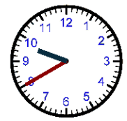 2.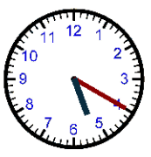

_______________________________________ _______________________________________

3.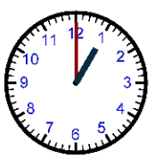 4. 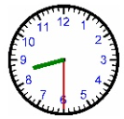

_______________________________________ _______________________________________

5.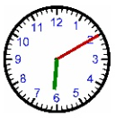 6.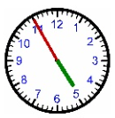

_______________________________________ _______________________________________

Singular Pronouns | Plural Pronouns
(I) | (We)
(You informal) | (Y’all * in Spain)
(He, She, You formal) | (They, You all in Latin America)
- Can you list the Spanish subject pronouns for each one given in English??

- Can you fill in each blank with the correct conjugation of “ser” (to be)

