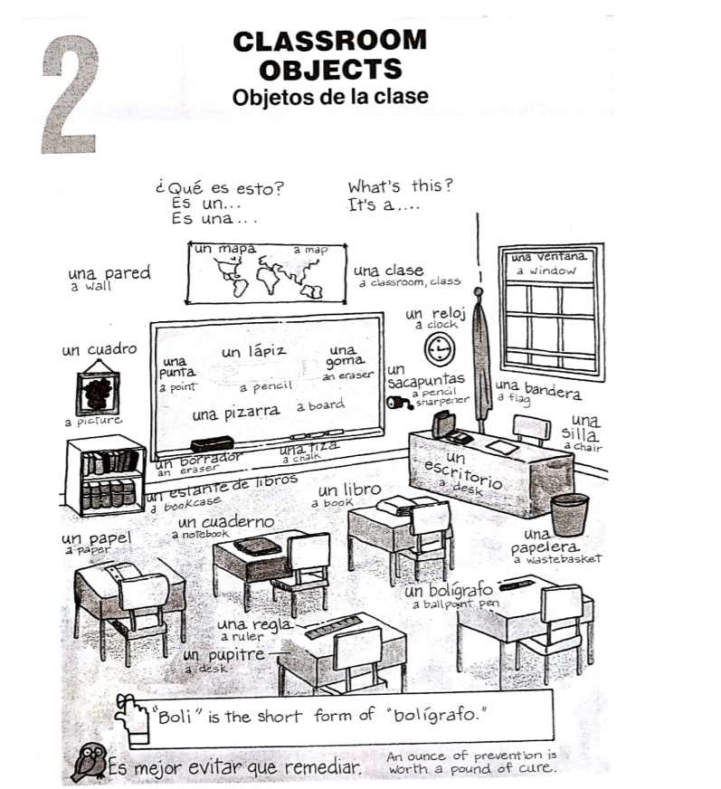

1. **How is each object used? Match Column B with Column A.**

A B

1. Un libro _______ a. lets in fresh air and daylight
2. Una ventana _______ b. gives you a place to throw used paper and trash
3. Un cuadro _______ c. where the teacher gets their work done.
4. Una papelera _______ d. makes a plain wall look more attractive
5. Un sacapuntas _______ e. makes a dull point sharp
6. Un escritorio _______ f. opens up new worlds of adventure, fantasy, travel, and information
7. Una regla _______ g. measures the length of something
8. **Identify each of the following illustrations. (En español, por favor).**
9. 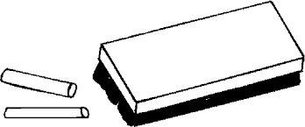 Es un _________________ 2. 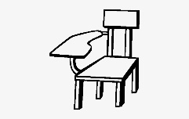 Es un _________________
10. 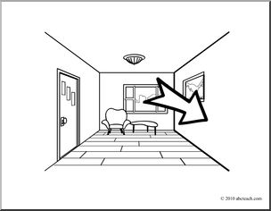Es una _________________ 4. 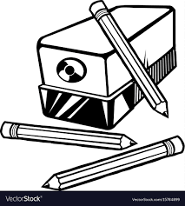 Es un _________________
11.  Es una _________________ 6. 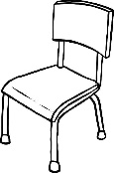Es una _________________
12. 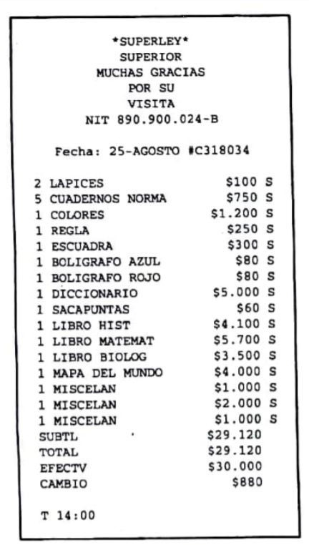**Look at the following shopping receipt for the school supplies that Patricia bought, and then answer the questions. (Patricia paid with Colombian pesos.)**
13. Where did Patricia buy her school supplies?
14. When did she go shopping?
15. At what time did she pay for her purchases?
16. How many pencils did she buy?
17. How much did she pay for the ruler?
18. How many pens did she buy?
19. What cost 60 pesos?
20. How many books did she buy?
21. What cost 4,000 pesos?
22. What was her most expensive purchase?
23. **Complete the crossword puzzle using the clues below**



B

A

S

U

R

E

R

O

**Vertical** **Horizontal**

1. Written on with pen or pencil 4. Window
2. Makes a point sharp 6. Drawing
3. Notebook 8. Place to sit
4. The teacher’s desk 10. Writing instrument (shortened word)
5. Displays countries and oceans 13. Measures things
6. Needs sharpening 15. Teacher writes on this when presenting
7. Garbage can 16. Read by students
8. Where a student sits 17. Holds/organizes books (“…de libros”)
9. A group of students taking the same course 19. Removes written mistakes
10. Cleans whiteboards
11. Use this to write on a chalkboard
12. **Name the classroom object more closely associated with the following clues. (En español, por favor).**
13. 9:00 / 5:30 / 1:45 / 7:52 ___________________________________
14. Guatemala / Canada / China ___________________________________
15. The Great Gatsby / The Outsiders / The Adventures of Tom Sawyer _________________________
16. **List 6 classroom items you have in your backpack (En español, por favor).**
17. ______________
18. ______________
19. ______________
20. ______________
21. ______________
22. ______________