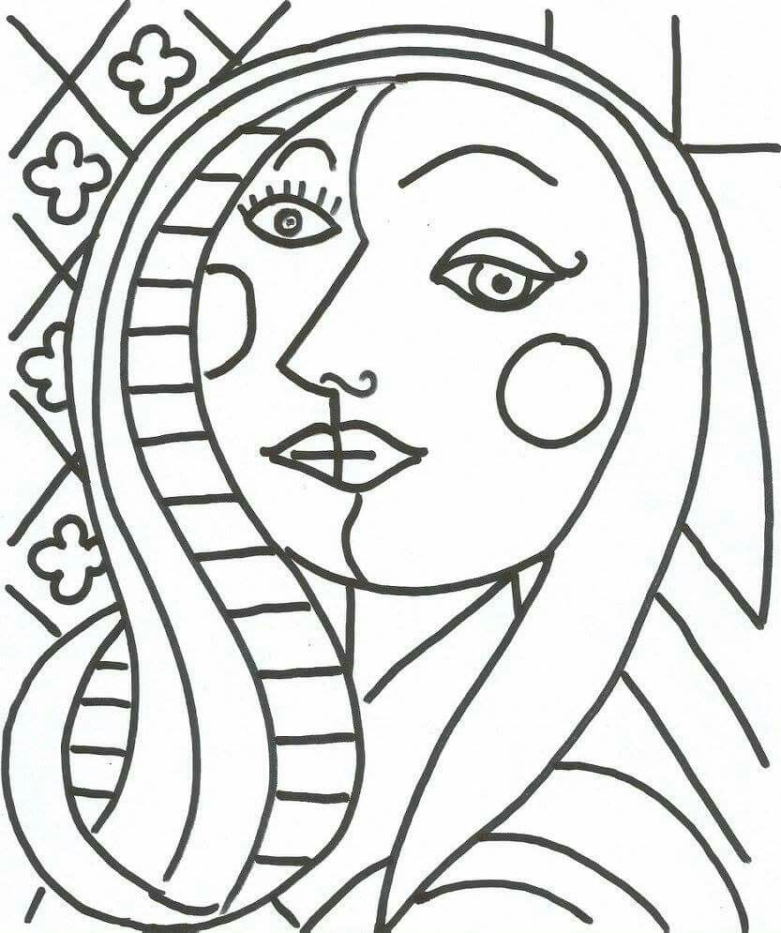

3

5

9

9

3

11

5

9

9

5

9

12

13

5

13

13

3

13

9

**5**

5

3

3

3

10

10

10

6

6

6

8

8

8

8

8

8

8

7

7

7

7

7

7

7

7

4

4

2

2

2

2

2

2

2

2

2

4

4

1

1

1

Nombre _____________________________________ Fecha (Date) _________________________

________# silla (chair #)

**El Arte de Pablo Picasso**

A. Colorea por los números (Color by the numbers)

B. Escribe el color en español en el espacio. (Write the name(s) for each color in Spanish)

1. brown ____________________________ / ____________________________

2. pink ____________________________ / ____________________________

3. red ____________________________

4. white ____________________________

5. blue ____________________________

6. yellow ____________________________

7. black ____________________________

8. purple _____________________ / _____________________ / _____________________

9. green ____________________________

10. orange ____________________________

11. gray ____________________________

12. silver ____________________________

13. gold ____________________________