**Guided Notes   
La Hora (Time / The Hour)**

**Time-related vocab**

* AM _______________________
* PM (afternoon) _______________________
* PM (night) _______________________
* Noon _______________________
* Midnight _______________________
* sharp (on the dot) _______________________
* :30 _______________________
* :15 _______________________

**MCj04109290000[1]¿Qué hora es? = _____________________________________**

1:00 = _____________________________________

1:25 = _____________________________________

2:00 = _____________________________________

5:15 = _____________________________________

5:30 = _____________________________________

10:10 = _____________________________________

**What time is it? Write the answer in Spanish**

**2:10 ____________________________________________**

**5:24 ____________________________________________**

**9:00 ____________________________________________**

**1:00 ____________________________________________**

**8:29 ____________________________________________**

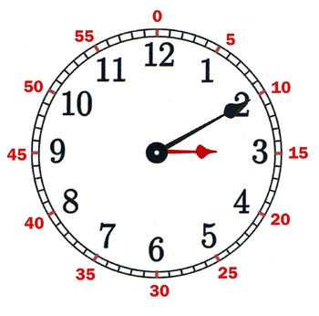

1. 10:50am _________________________________
2. 4:30am _________________________________
3. 9:00 sharp _________________________________
4. 1:45pm _________________________________
5. 11:15pm _________________________________
6. 7:55am _________________________________
7. 2:20pm _________________________________
8. 8:53pm _________________________________