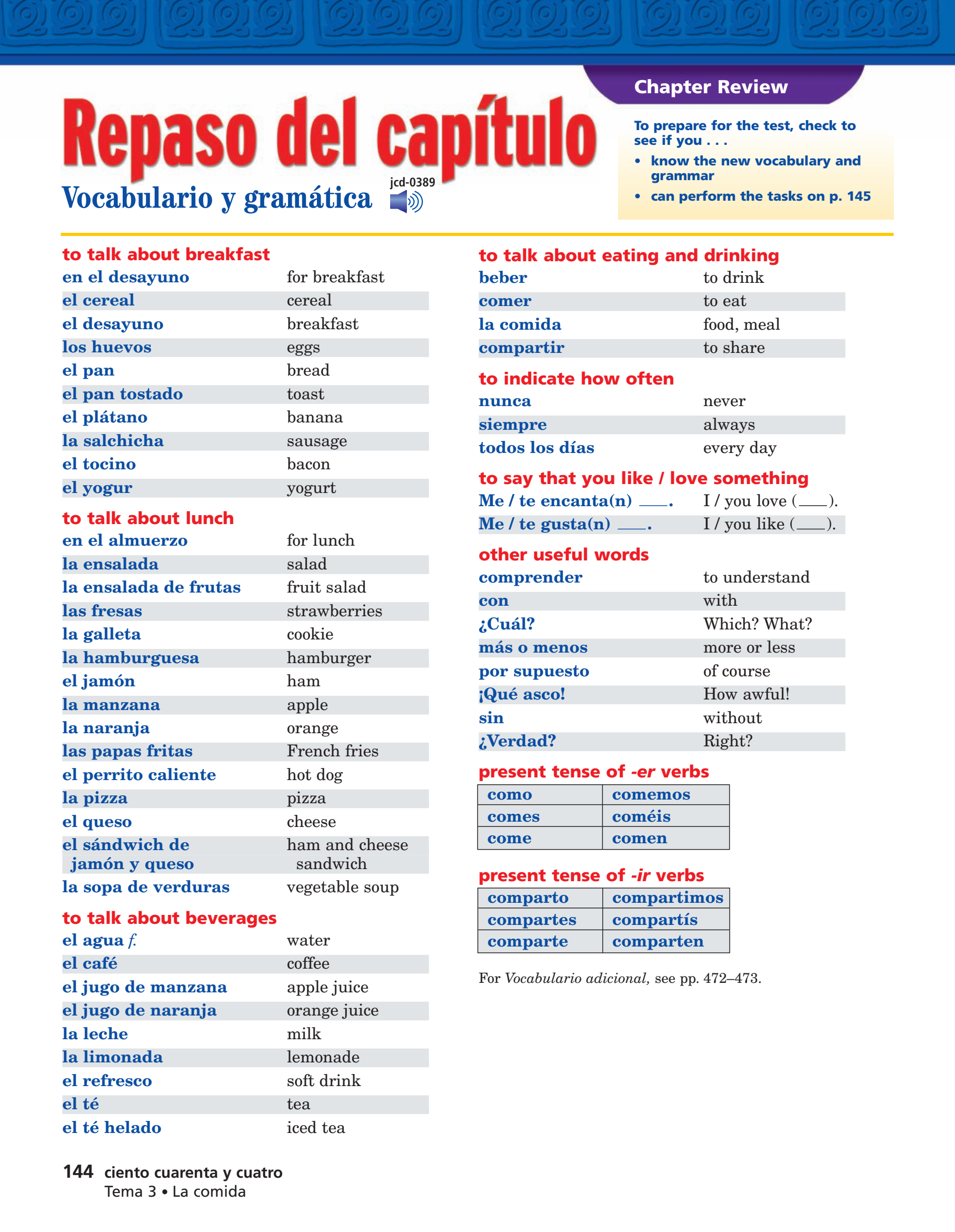
¿Desayuno o almuerzo?
Esp. 1 Cap. 3A

Horizontales

5. iced tea
6. more or less
9. yogurt
11. with
13. to eat
16. Right?
22. fruit salad
23. food, meal
24. toast
26. eggs
28. french fries
32. of course

35. cereal
36. orange
38. to drink
39. cookie
40. salad
41. hamburger
42. Which? / What?
43. always
44. every day
45. ham
46. coffee

Verticales

1. milk
2. pizza
3. lemonade
4. how awful!
7. apple juice
8. without
10. strawberries
11. to share
12. to understand
14. apple
15. banana
17. water

18. never
19. tea
20. soft drink
21. cheese
25. orange juice
27. I love ____.
29. lunch
30. bacon
31. vegetable soup
32. hot dog
33. sausage
34. bread
37. breakfast

